[](http://www2.wcpss.net/)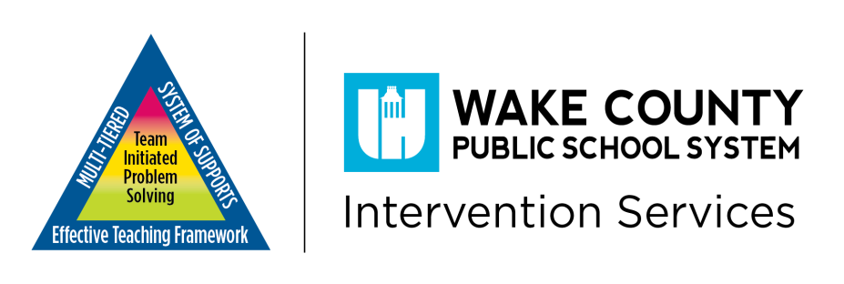

**Multi-Tiered System of Supports (MTSS)**

Information for Parents

**Mission**

*The Wake County Public School System will significantly increase achievement for all students by providing a world class education that equips students with the knowledge and expertise to become successful, productive citizens.*

What is Multi-Tiered System of Supports?

**MTSS Essential Components**

* **Data-based Decision Making**-the use of student data to guide design, implementation and adjustment of instruction.
* **Screening**-screening of students enables educators to establish an academic and behavioral baseline and to identify learners who need additional support.
* **Tiered Model of Delivery**-the tiers delineate levels of instructional interventions based on student skill need.
* **Progress Monitoring**-a scientifically based practice used to assess students’ academic performance and evaluate the effectiveness of instruction and/or intervention.
* **Fidelity of Implementation**-using instruction or materials in the way they are supposed to be used.

C:\Program Files\Microsoft Office\MEDIA\CAGCAT10\j0299125.wmf

*Multi-Tiered System of Supports is an approach used to increase the opportunity for all students to meet academic achievement standards through early identification of students whose academic and/or behavioral needs place them at risk. Multi-Tiered System of Supports ensures that resources and interventions are appropriately targeted to serve all struggling learners as early as possible through high-quality instruction.*

What Does MTSS Look Like?

The MTSS process has tiers that build upon one another. Each tier provides more intensive levels of support:

**Tier 1 Core Instruction.** The school provides all students with access to high quality curriculum, instruction, and behavior supports in the general education classroom.

**Tier II includes supplemental small group strategic instruction/intervention in addition to Core Instruction.** The school provides interventions to small groups of students who needmore support than they are receiving through Tier I.

**Tier III includes intensive instruction/intervention and ongoing assessments.** The MTSS Team engages in a problem-solving process and by continually monitoring and modifying (as needed) each student’s plan, the team is able to design an effective, individualized instructional program. Your child’s progress in monitored and results are used to make decisions about additional instruction and prevention.

***How Can Parents Make the Difference?***

● Communicate with your child’s teacher(s) ● Ensure that your child attends school regularly

● Encourage your child to do well in school ● Understand assessments your child takes

● Collaborate with your child’s school ● Ask how you can help your child at home

[](http://www2.wcpss.net/)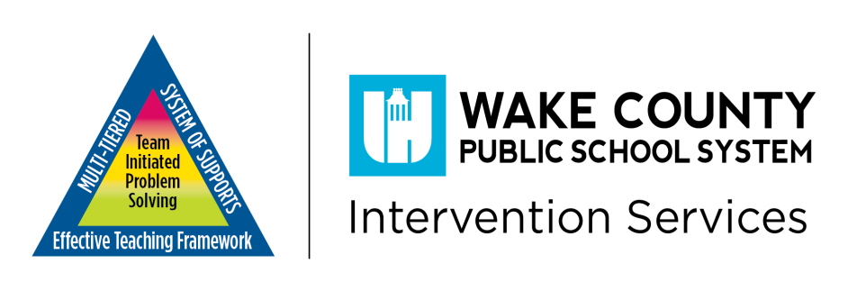

**Multi-Tiered System of Supports (MTSS)**

Information for Parents

Information for Teachers and Parents

**Does your Student Exhibit any of the Following Difficulties?**

**Lack of Motivation, Interest or Attention**-student is resistant or unwilling to participate in school activities and assignments or is inattentive in class.

**Homework Frustrations**-student argues about doing homework, cries or has tantrums, or requires your assistance to complete homework assignments.

**Behavior Problems**-student is acting up in class, seeking help or attention from other students.

**Slipping Grades**-student’s grades are steadily declining, indicating the schoolwork is either too difficult or your child lacks the skills needed to complete the tasks.

**Low Self-Esteem**-student avoids talking about school with you, becomes withdrawn or makes negative comments about his or her abilities.

**What Do Parents Do If They Believe Their Child Is Struggling?**

*Parents play a critical role in supporting what their children are learning in school. The more parents are involved in student learning, the higher the student achievement. Ask questions to learn more about this process:*

* Talk with your child’s teacher. Ask questions about teacher expectations and how you can help at home with your student.
* Review and assist with homework assignments. Does my child need a tutor?
* Celebrate your child’s successes!
* Ask for regular progress monitoring reports.
* Learn more about the curriculum (courses the school offers), assessments (documentation), and interventions (strategies for success), being used in your child’s school.
* Participate in conferences and other meetings about your child.
* Make a list of specific questions to ask during conferences (e.g., what is working or what additional supports may be needed?).

Sources: MDPI, National Center for Learning Disabilities

For further information contact your School’s Principal or your Central Office Staff. Contact information can be found at www.wcpss.net